**LAB -3: MASHUP APPLICATION**

I have created an web app which uses the Yahoo finance data to generate stocks statistics of google and Facebook. So watching the same the user can analyze the data and invest according to his need.

In the application, code was written in jsfiddle environment using HTML, JavaScript and CSS by using the API of Twitter, Facebook, Yahoo Finance, and YouTube. The application being used is as shown in the screen shots below.

When the code executed:

We get the statistics of google and facebook from Yahoo finance.

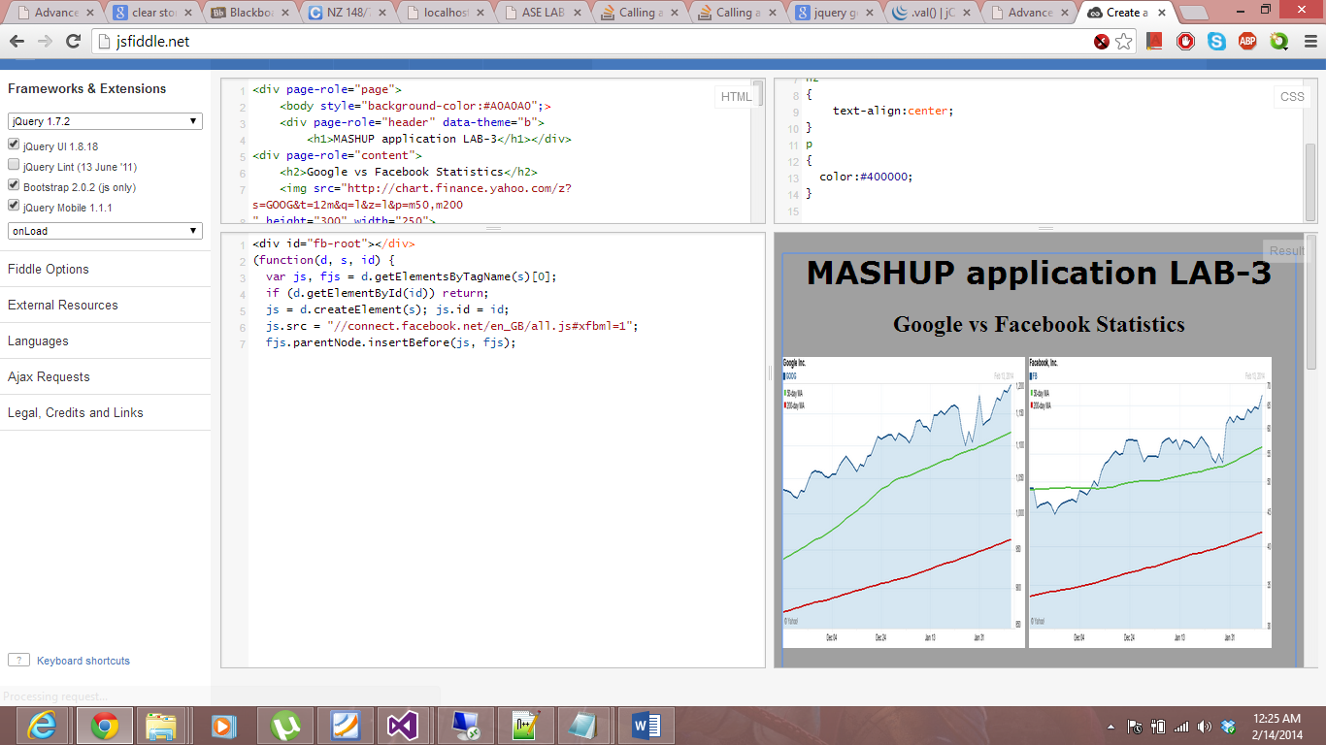

If the user is satisfied with the results and want to invest money in either of the companies then a link for ETRADE and window is provided.

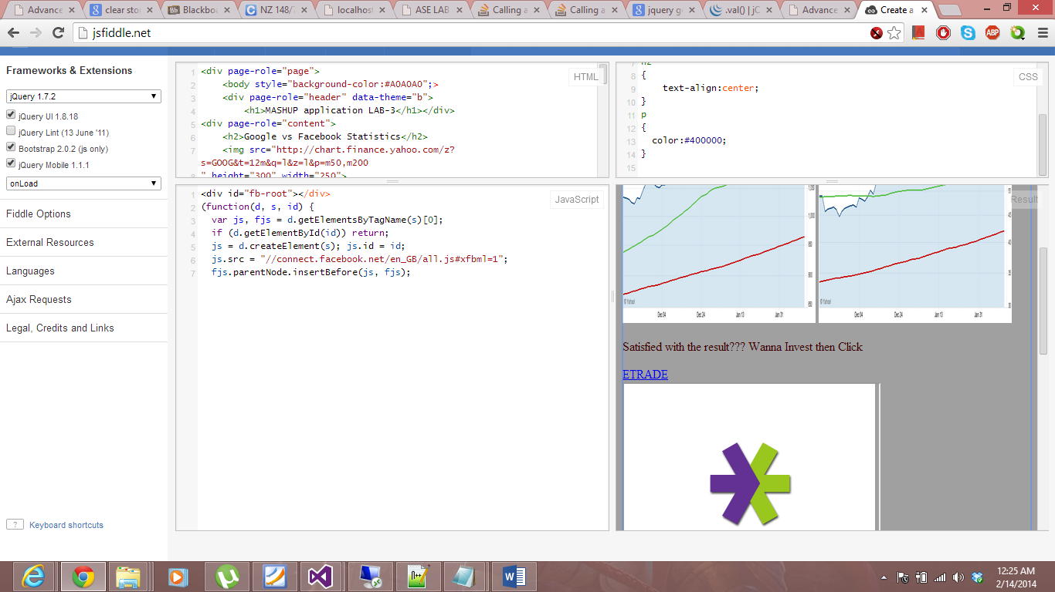

The user can login into ETRADE to buy shares if he wants to.



If the user wants to know more about the companies a video box from YouTube is provided to watch the video.

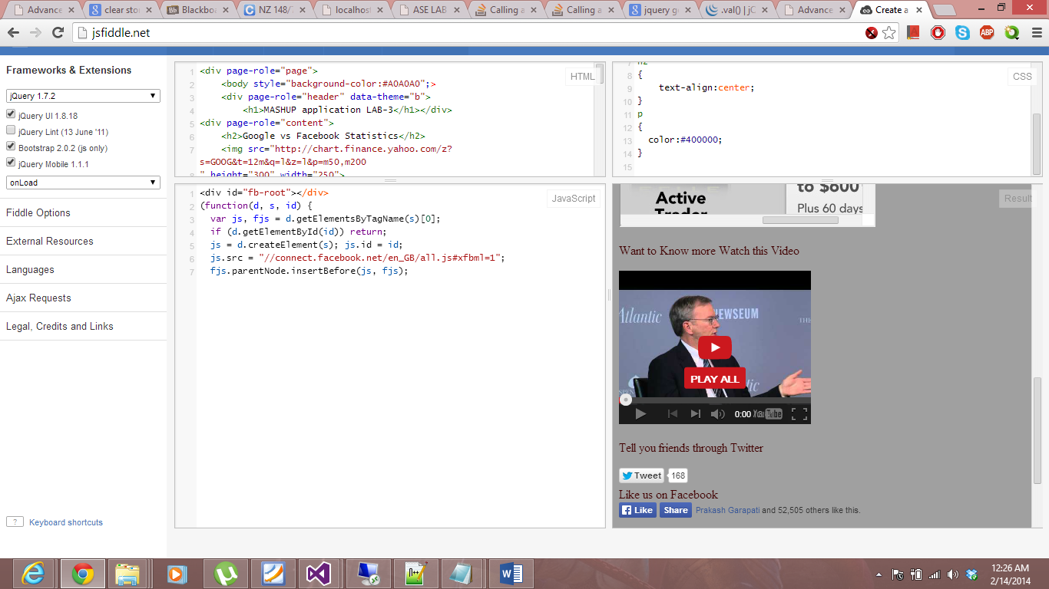If you want to share anything with friends through twitter a link is provided using the Twitter API. Click on it and share.

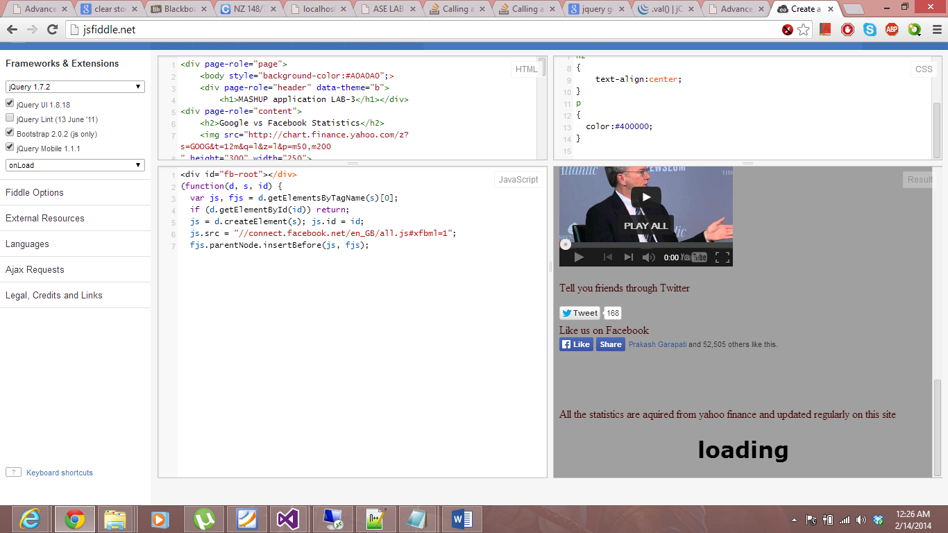

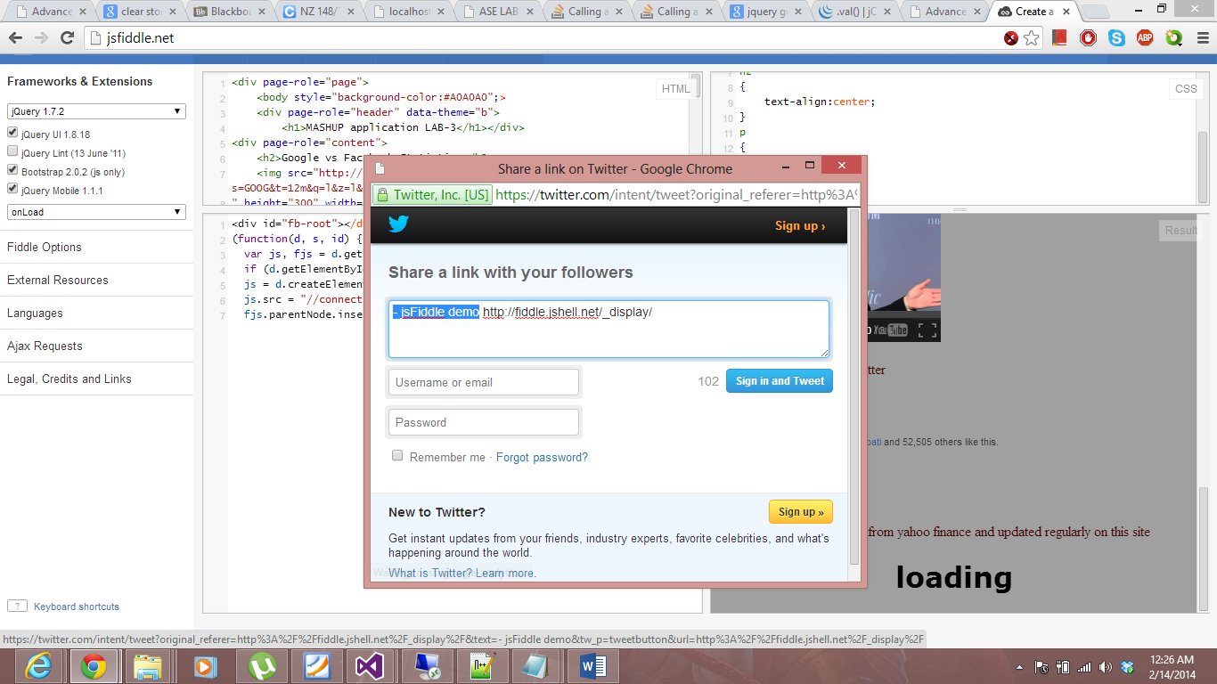

If the user want to like the page on Facebook a like button is provided using Facebook API.

